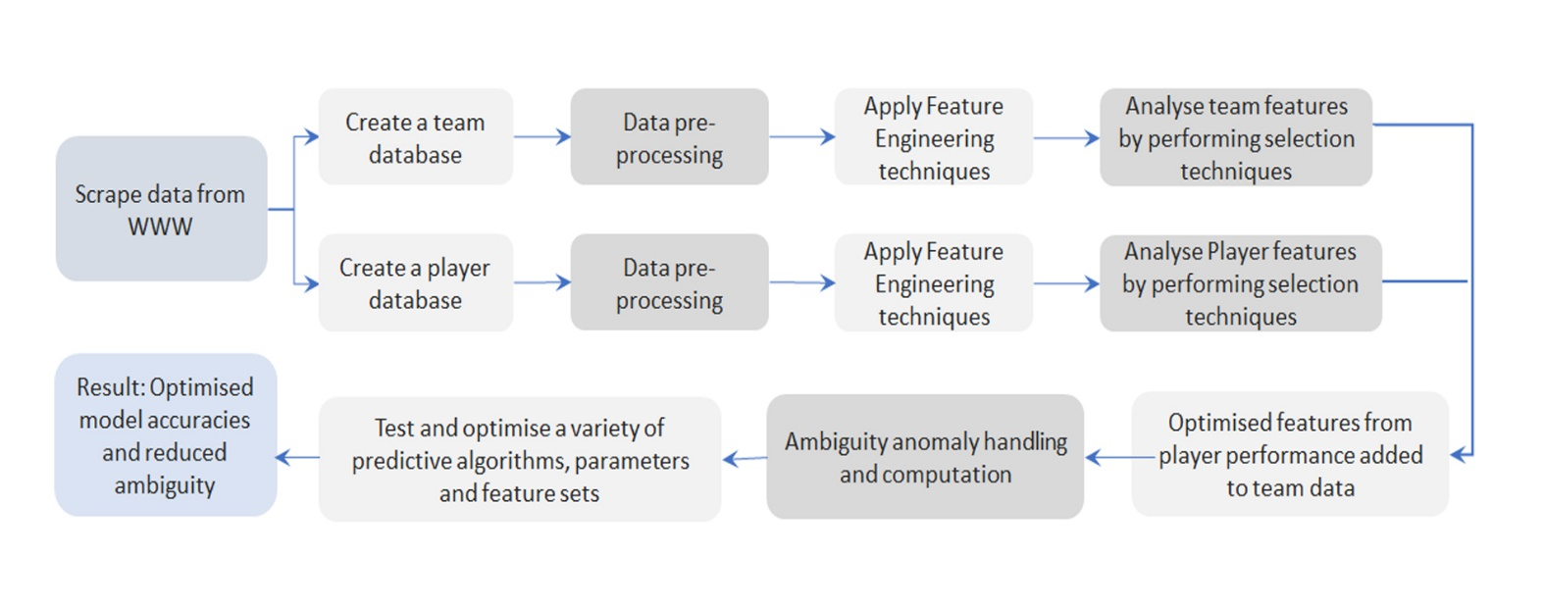

*Figure 1: Complete process from data scrapping to creating optimised model accuracies with reduced ambiguity for predicting IPL matches’ winner.*

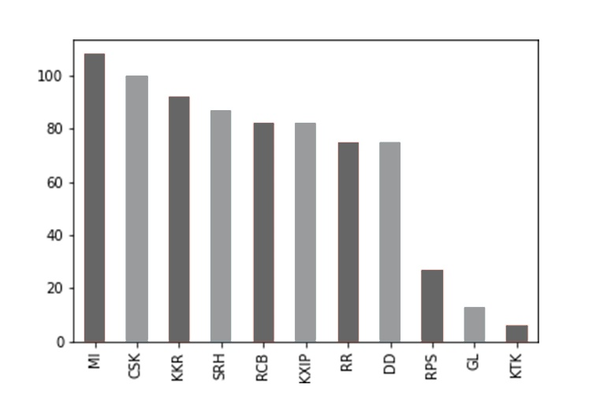

*Figure 2: Historical data of the number of times each participating team has won a match during the IPL*

*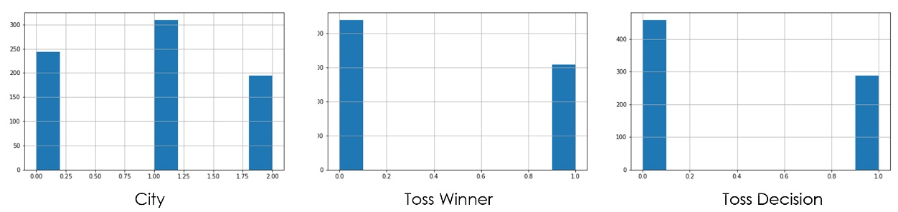*

*Figure 3: Feature Distribution of Base features*

*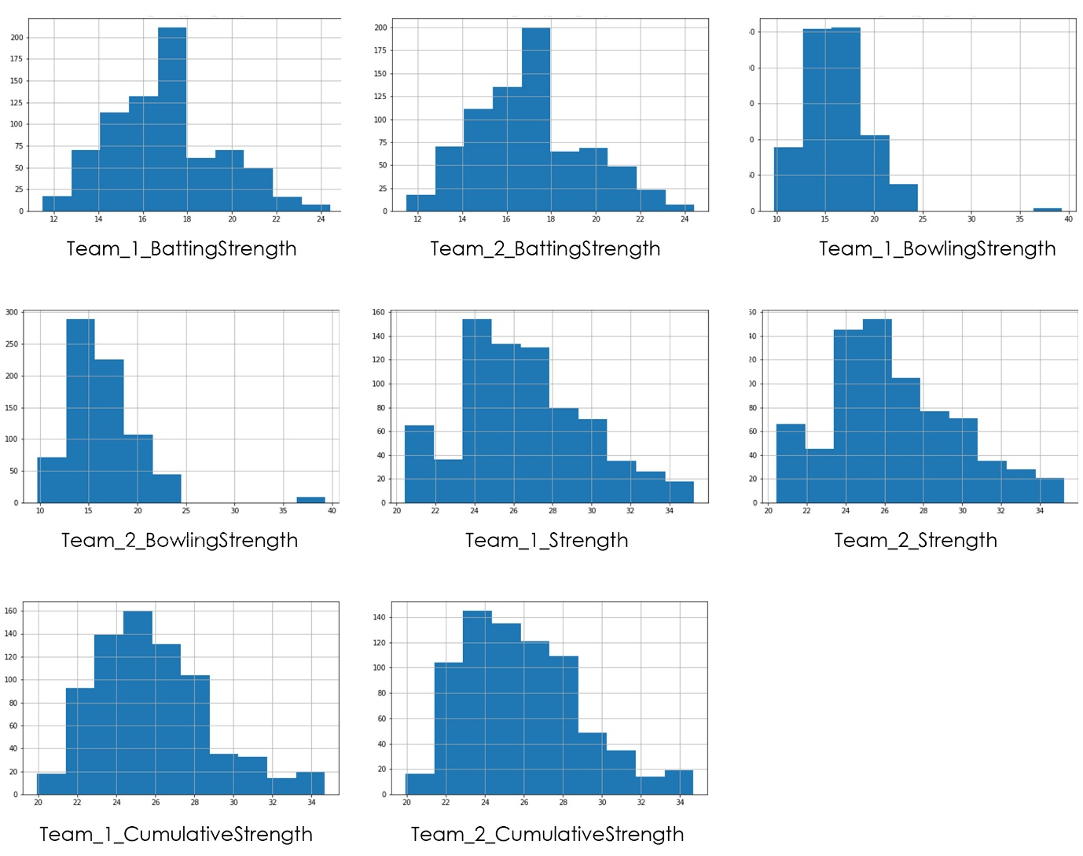*

*Figure 4: Feature Distribution of Dream 11 Strength Features*

*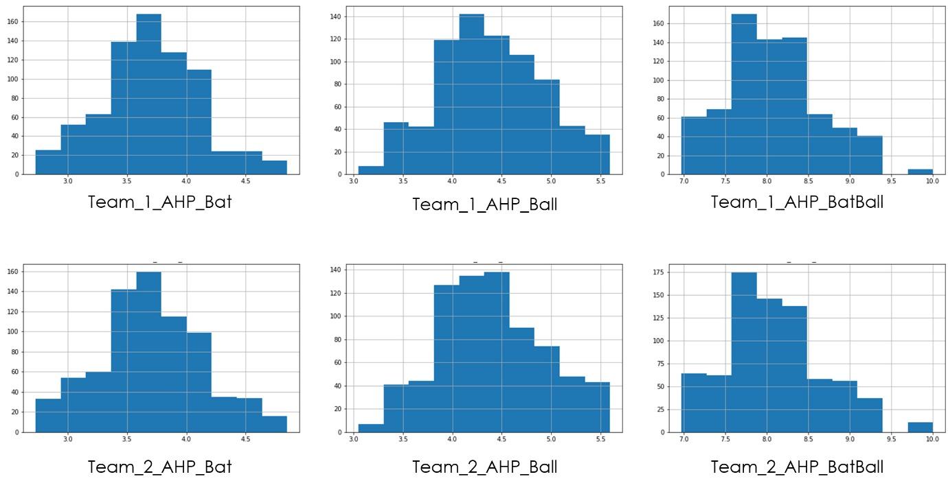*

*Figure 5: Feature Distribution of AHP Strength features*

*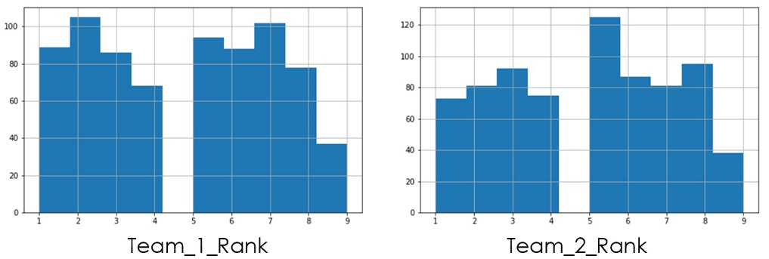*

*Figure 6: Feature Distribution of AHP Rank features*

*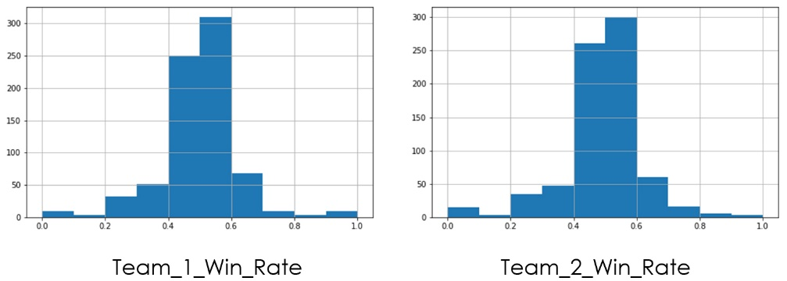*

*Figure 7: Feature Distribution of Win rate features*

*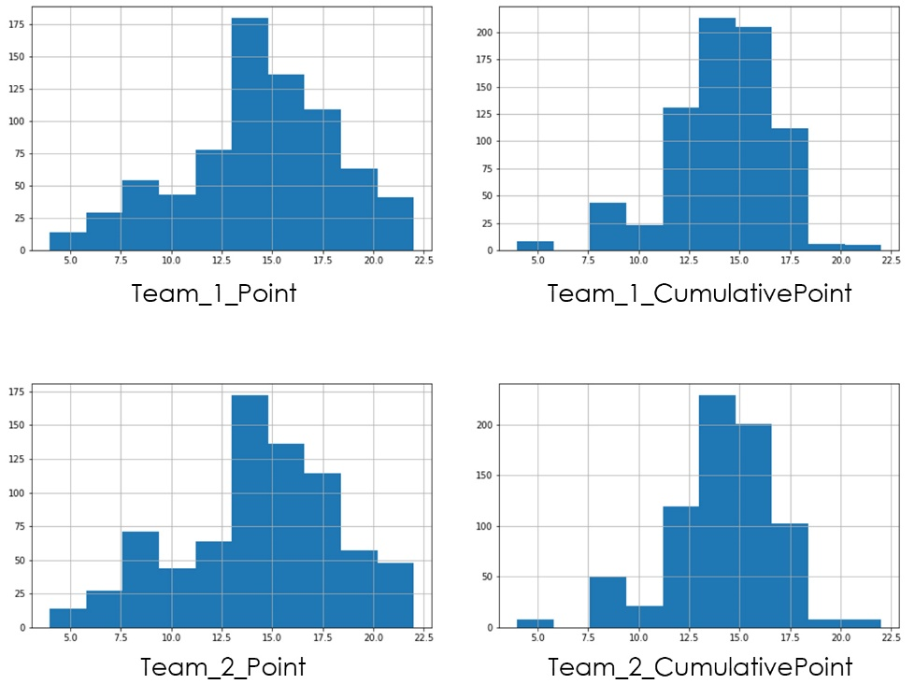*

*Figure 8: Feature Distribution of Team Point features*

*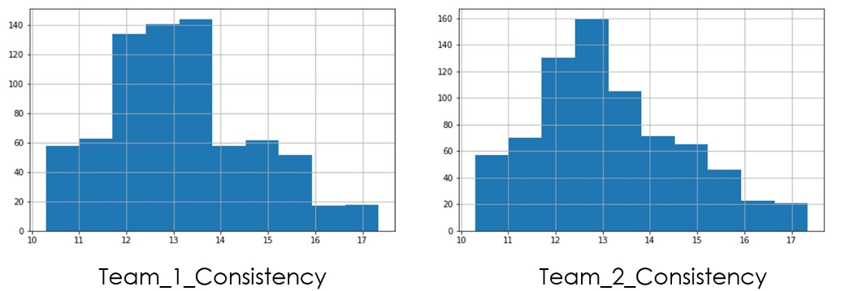*

*Figure 9: Feature Distribution of Consistency features*

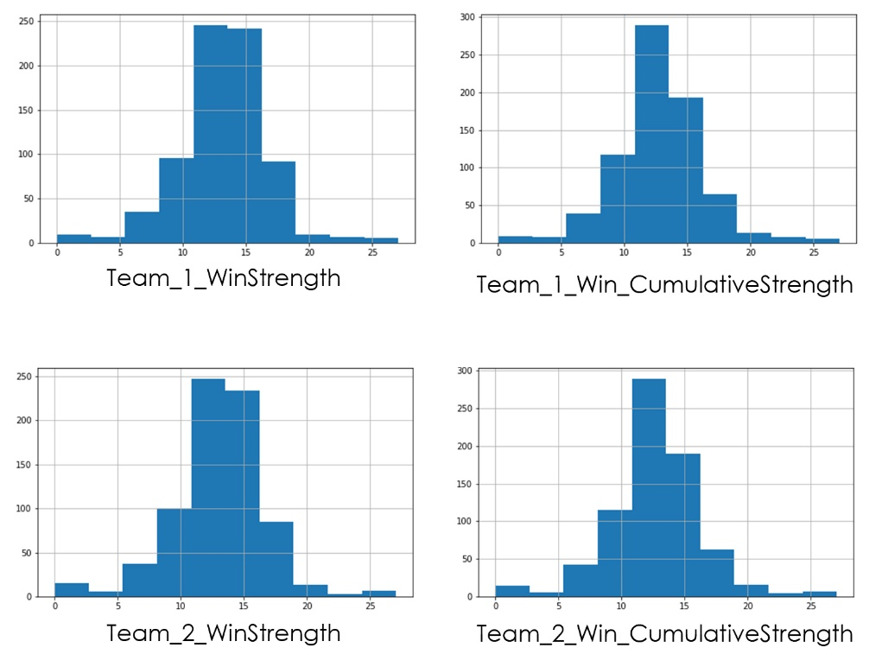

*Figure 10: Feature Distribution of Win Strength features*



*Figure 11: ROC curve and Real test accuracy distribution with Naïve Bayes*



*Figure 12: ROC Curve and Real test accuracy distribution with Logistic Regression*

*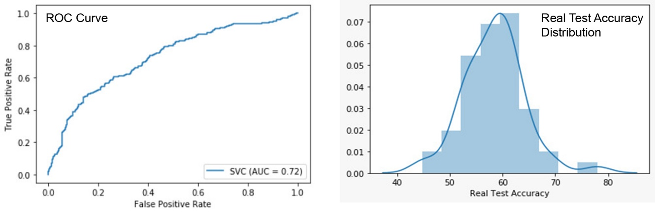*

*Figure 13: ROC Curve and Real test accuracy distribution with SVM*

*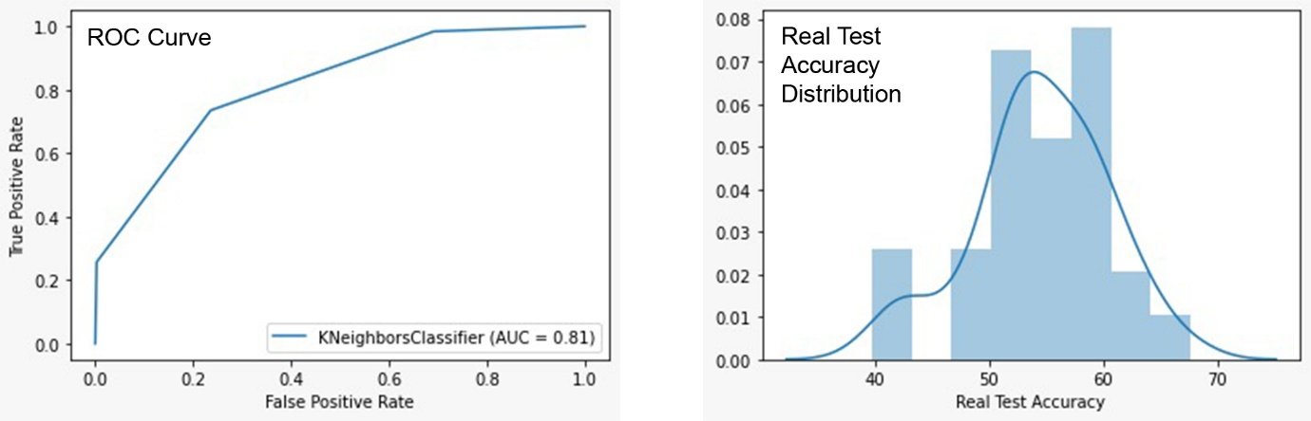*

*Figure 14: ROC Curve and Real test accuracy distribution with KNN*



*Figure 15: ROC Curve and Real test accuracy distribution for AdaBoostClassifier*



*Figure 16: ROC Curve and Real test accuracy distribution for XGBOOST*



*Figure 17: ROC Curve and Real test accuracy distribution for Extra TreesClassifier*



*Figure 18: ROC Curve and Real test accuracy distribution for Random Forest Classifier*